ASSIGNMENT 3

QN 1 DATA SET

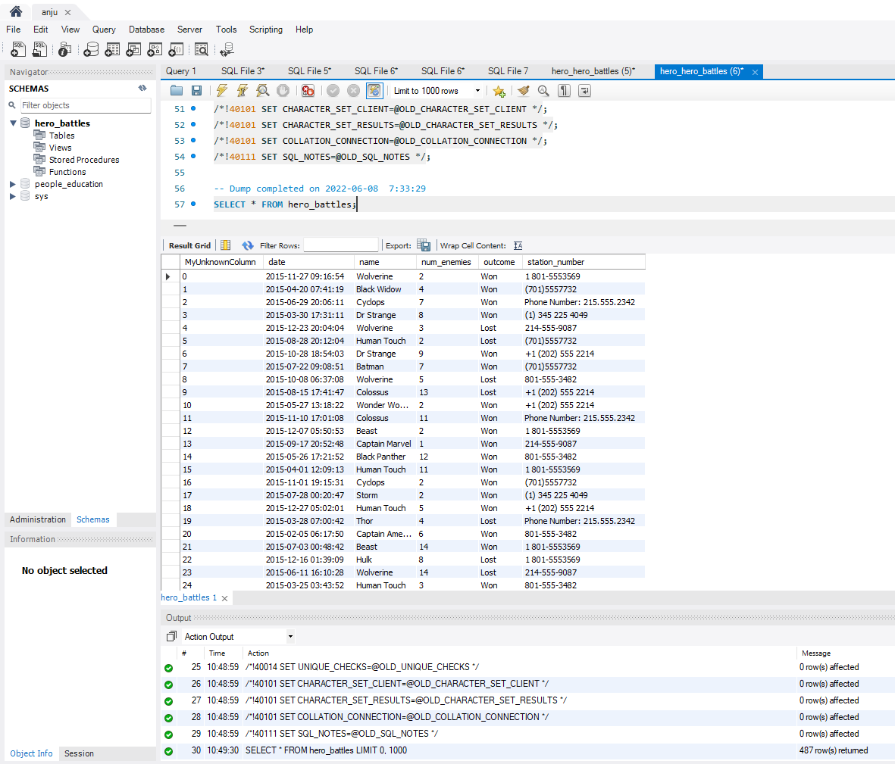

QN 2 Now, return the number of rows in the data set.

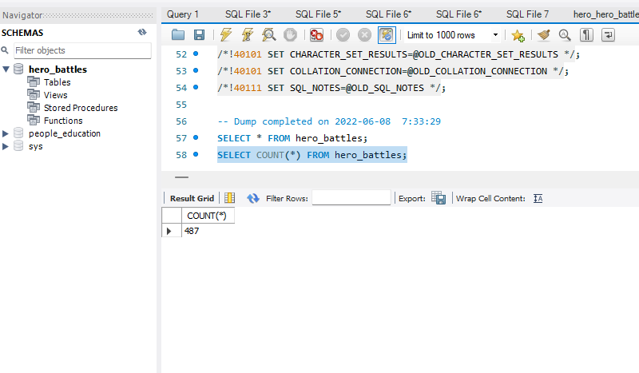

QN 3

Write a query to select the column name’s max and min. Hint: use MIN() and MAX().

SELECT MAX(name) AND MIN(name) FROM hero_battles;

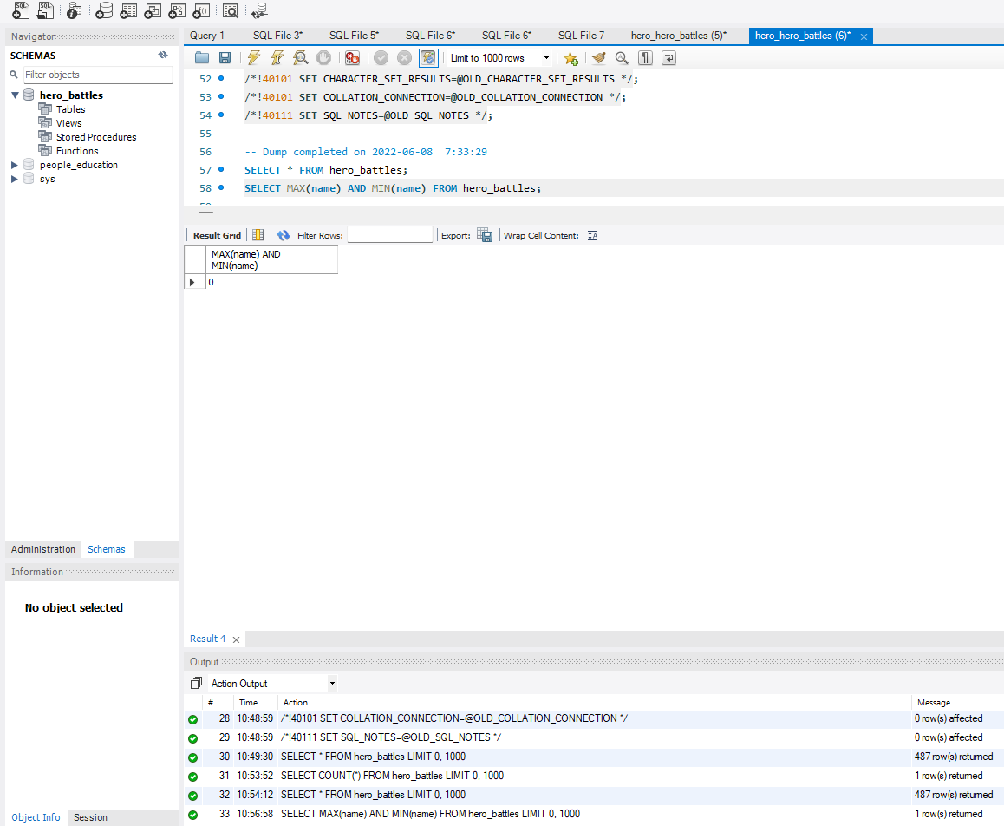

QN 4

Write a query to select both the sum and the average of the column num_enemies

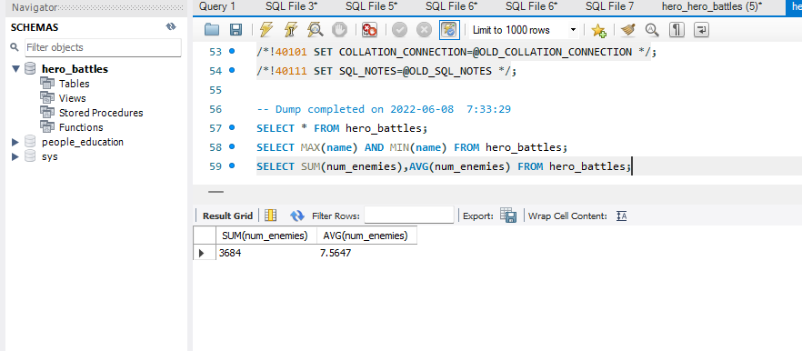

QN5

Now take that query of the sum and average of enemies, and group it by the column name

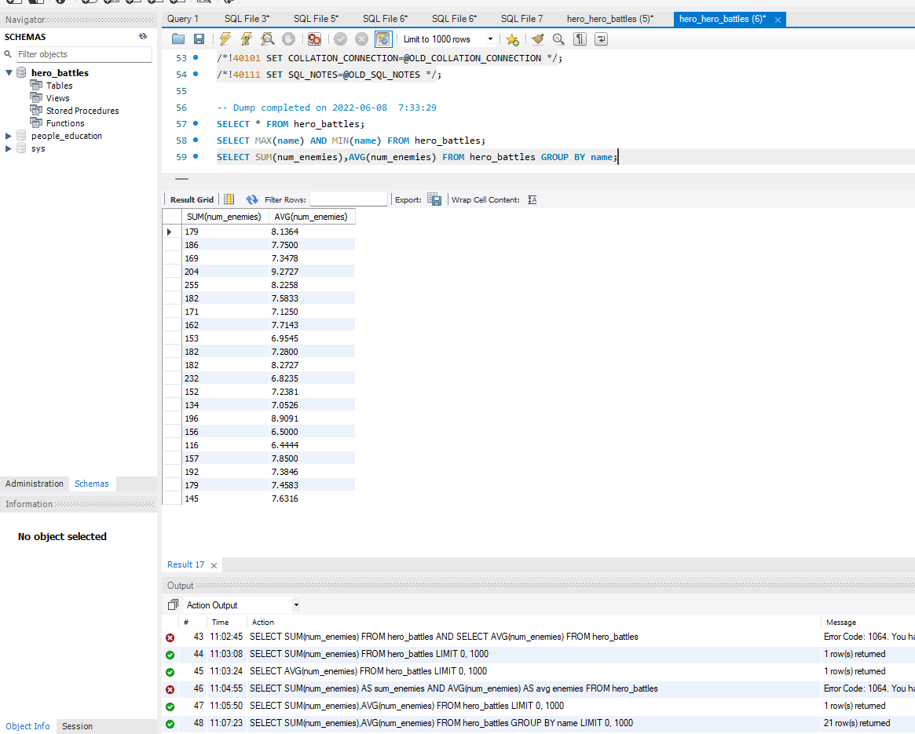

Qn6

take the query we’ve been building and ORDER by the average

